Objective:
The objective of this lab session is to help students learn and apply the concept of structures in C++ programming. Students will understand how to define, declare, and use structures to store and manage related data efficiently.

Introduction:
In C++, a structure (struct) is a user-defined data type that allows grouping variables of different data types under a single name. Structures are useful when dealing with complex data where multiple attributes are required to represent an entity, such as a student record or employee details.

Theory:
A structure is defined using the struct keyword. It can contain variables of different types such as integers, floats, and characters.
Syntax:
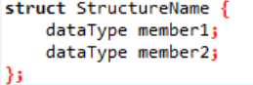
- Each variable inside the structure is called a member.
- Structure variables can be accessed using the dot (.) operator.

Conclusion:
In this lab, we learned how to use structures in C++ to store and manage multiple related data items. Structures improve program organization and make handling complex data easier.

Lab 13 Tasks:
1. Structure Declaration and Initialization:
- Declare a structure called Person with the following members:
– name
(string)– age
(integer)
– address (string).
- Declare a variable called person1 of type Person and initialize its members with
values of your choice.
- Display the values of the members of person1 using dot notation.
Code:
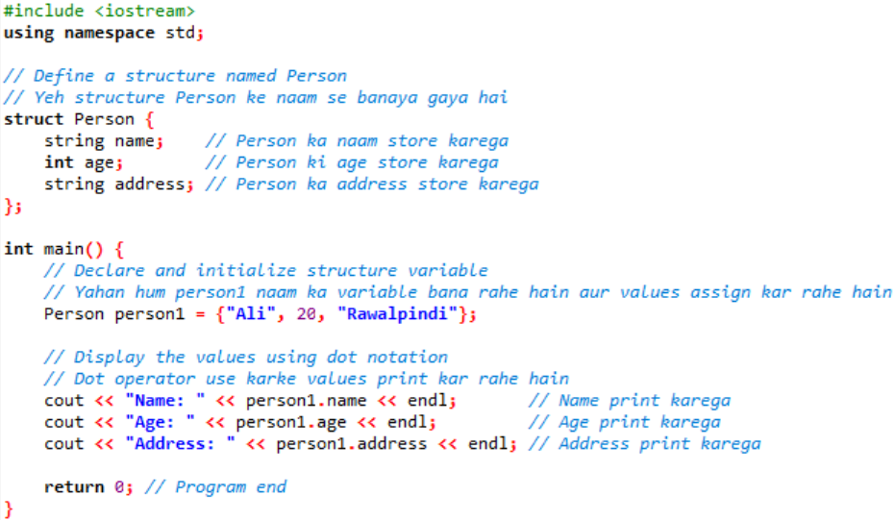
2. Structure Declaration and Initialization
- Declare a structure called Student with the following members:
– name
(string)– age
(integer)
– grade (char)
- Declare a variable of type Student called student1 and initialize its members with
values of your choice.
- Display values of student1 structure members.
Code:
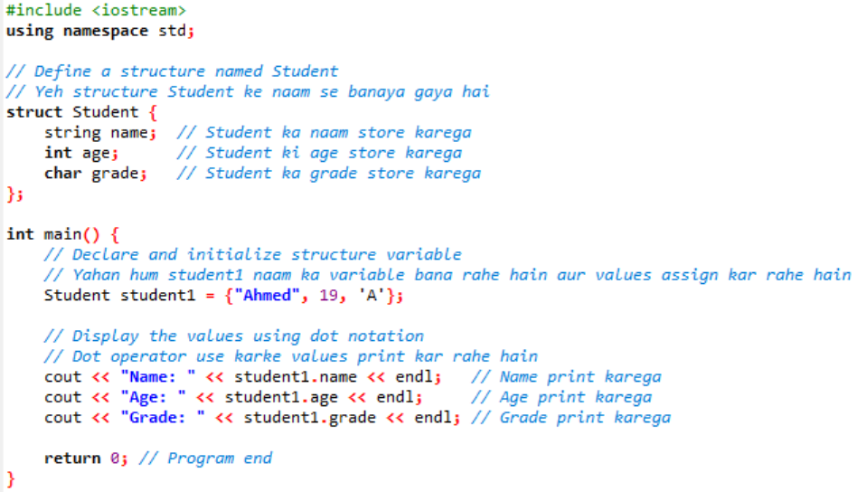

3. Accessing Structure Elements
- Declare a structure called Book with the following members:
– title (string)
– author
(string)– price
(float)
– pages (integer)
- Declare a variables of type Book called book1 and book2, anmd initialize its
- members with values of your choice.
- Display values of structure members of variables book1 and book2 .
Code:
